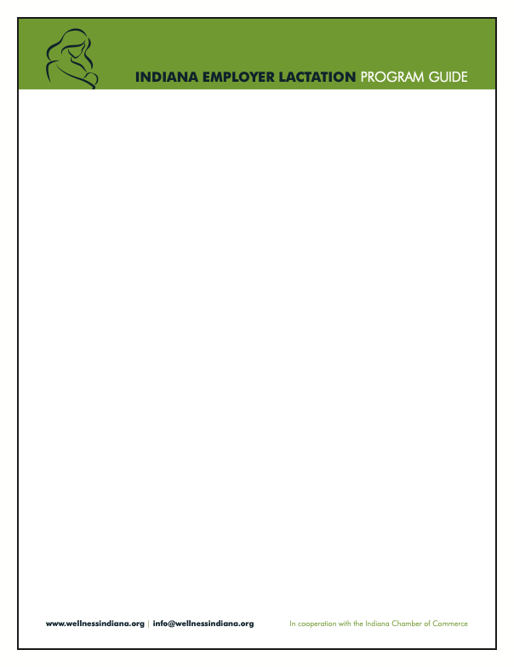

Sample Pregnancy and Parental Leave HR Checklist

HR Representative
☐ Create a lactation welcome packet for new or expecting mothers to streamline information and offer early support.
- This packet can include:
  - Sample Lactation Policy
  - Sample Employee Lactation Support Handbook
  - Sample Employee FAQ
    - Include EAP information or any other company-provided mental health resources to support overall well-being
    - Note whether breast pump coverage is included in the health plan and provide details on how to access or request coverage
  - Employee Resource List
  - Sample Father, Spouse and Partner Welcome Guide

Acknowledgement of pregnancy
Employee
☐ Employee informs HR or direct supervisor (preferably in writing, adjust based on your company’s policy)
HR representative
☐ HR schedules a private meeting to discuss:
☐ Estimated due date
☐ Parental leave policies and rights
☐ Potential health accommodations or schedule flexibility
☐ Provide employee with:
☐ Parental leave policy documentation
☐ Lactation welcome packet
☐ Health and safety guidance and resources
☐ Contact information for HR support
☐ Confirm whether a risk assessment is needed for the role (physical jobs, chemicals, etc.)
☐ Document all communications in personnel file

Planning for parental leave
Employee
☐ Receive estimated due date confirmation (e.g., from doctor)
HR representative
☐ Discuss anticipated start and end dates of parental leave
☐ Clarify paid vs unpaid leave, insurance coverage and any short-term disability plans
☐ Confirm use of PTO, sick leave or other paid benefits
☐ Collaborate with supervisors to develop a coverage plan for employee’s responsibilities
☐ Notify payroll and benefits teams of upcoming leave dates
☐ Set expectations for communication during leave (if any) and confirm contact information


Legal and documentation requirements
HR representative
☐ Confirm eligibility under FMLA (if applicable)
☐ Provide and collect necessary leave request forms
☐ Share information on benefits continuation during leave
☐ File required paperwork (FMLA, short-term disability, state leave forms, etc.)
☐ Update internal systems (HRIS, payroll, benefits)

Pre-leave preparation
Employee
☐ Ensure all work handoffs and transitions are complete
☐ Schedule a final check-in meeting before leave begins
HR representative
☐ Provide employee with re-onboarding expectations and return process
☐ Provide employee with a tour of the designated lactation space and scheduling system

During parental leave
HR representative
☐ Maintain appropriate contact (check-ins only if mutually agreed upon)
☐ Ensure continued compliance with benefits and legal requirements
☐ Send congratulations when the baby arrives (optional/personalized)

Preparing for return
Employee
☐ Confirm return-to-work date
Supervisor/manager
☐ Review any updates to policies, team structure or systems
☐ Prepare workspace and reinstate system access
☐ Ensure lactation accommodations are arranged (flexible scheduling/break times, space preparation, communicate with supervisor, and ensure the parent’s needs are met)

Return and re-onboarding
HR Representative
☐ Conduct return-to-work meeting:
☐ Address any concerns or needs (lactation needs, childcare, flexible scheduling/tapered workload, benefits update, etc.)
☐ Go over any updates the employee may have missed (changes to structure or policy, systems or software, etc.)
☐ Plan an employee/supervisor meeting to discuss project and priority changes, lactation schedule and coverage, access to tools, systems and communications
☐ Provide lactation welcome packet highlighting the resources
☐ Monitor transition for first 30–60 days
☐ Schedule check-in at one month after return to work and two months post-lactation room usage to ensure well-being and support
☐ Document all communications in personnel file

