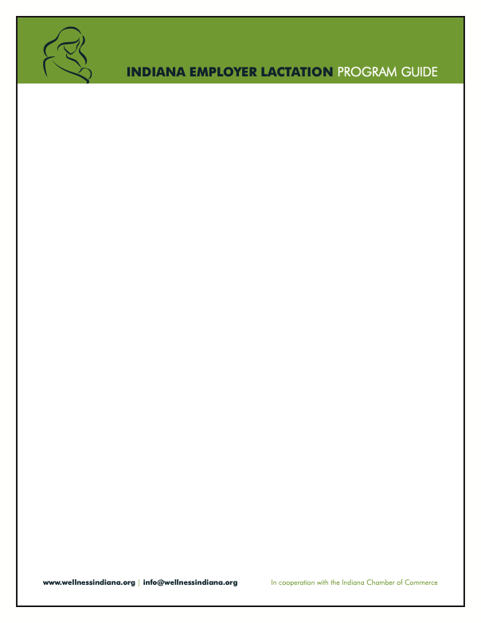

Sample Manager Training Guide for Lactation Accommodations

Introduction
Managers play a critical role in supporting breastfeeding mothers and ensuring compliance with both state and federal laws. This guide provides tools and knowledge to help managers create a supportive workplace environment.

Section 1: Understanding the Law
Managers must be familiar with the following laws:
- Fair Labor Standards Act (FLSA): Requires reasonable break time and a private, non-bathroom space for milk expression
- Affordable Care Act (ACA): Mandates coverage for breastfeeding support and supplies
- Indiana State Laws: Similar requirements as federal laws and applies to employers in the state of Indiana regardless of size
- Key takeaway: Employers must provide adequate break time and private space, free from intrusion, for employees to express milk

Section 2: Manager Responsibilities
- Provide break time:
  - Collaborate with employees to schedule breaks as needed
  - Breaks may align with regular rest or meal breaks
- Ensure access to lactation space:
  - Verify the availability of a clean, private space
  - Ensure the space is not a restroom and has essentials (e.g., chair, outlet, refrigerator access)
- Communicate openly and respectfully:
  - Maintain confidentiality
  - Foster an environment where employees feel comfortable discussing lactation needs
- Address concerns quickly:
  - Proactively manage any scheduling or space-related conflicts
  - Escalate concerns to HR if unresolved
Key takeaway: Supportive managers build trust and improve employee retention

Section 3: Creating a Supportive Culture
- Encourage open conversations about lactation support needs
- Avoid stigmatizing or dismissive language
- Celebrate a workplace culture that values work-life balance and family needs
Example conversation starters:
- “How can I best support you during your return to work?”
- “What can I do or provide to help make this transition easier?”
- “Are the break times and lactation space working well for you?”


Section 4: Troubleshooting Common Scenarios
- Scenario: No available lactation space
  - Solution: Identify a temporary private space with minimal disruption
- Scenario: Scheduling conflicts with lactation breaks
  - Solution: Collaborate with the employee to adjust workflows or coverage
- Scenario: Employee feels uncomfortable raising lactation concerns
  - Solution: Foster a safe and respectful environment for open communication

Section 5: Resources for Managers
- Lactation Support Policy document
- HR contact information
- Local lactation resources

Checklist for managers
☐ Understand lactation laws and policies
☐ Provide a private lactation space
☐ Schedule reasonable lactation breaks
☐ Foster open communication
☐ Address concerns promptly and respectfully

Final note: Supporting lactating mothers isn’t just about compliance – it’s about fostering a positive workplace culture.

For questions or support, contact [HR contact info]

