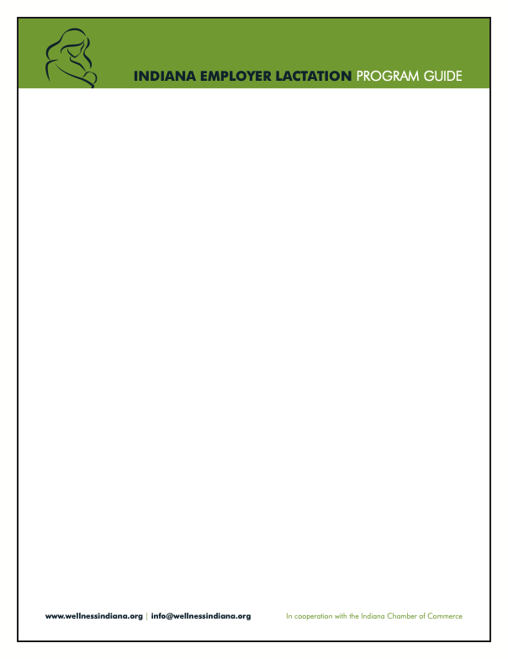

Sample Employee Lactation Support Needs Assessment Survey

Purpose:
This survey helps us understand how [company name] can better support lactating mothers in the workplace. Your responses are confidential and will only be used to improve our lactation accommodation program.

Survey Questions:
Section 1: Current Awareness and Needs
- Are you currently pregnant, breastfeeding or planning to breastfeed in the next 12 months?
  - Yes
  - No
  - Prefer not to say
- Are you aware of our company’s lactation support policy and available resources?
  - Yes
  - No
- Have you used or do you plan to use lactation accommodations at work?
  - Yes
  - No
  - Not sure

Section 2: Workplace Accommodations
- Does your workplace currently have a designated private lactation space?
  - Yes
  - No
  - Unsure
- What features are most important to you in a lactation space? (Select all that apply)
  - Privacy
  - Electrical outlet
  - Comfortable seating
  - Refrigerator for milk storage
  - Sink nearby for cleaning
  - Access to water
- Do you feel comfortable discussing lactation needs with your supervisor or HR?
  - Yes
  - No
  - Somewhat

Section 3: Break Times and Scheduling
- Do you feel you have adequate break time for lactation needs?
  - Yes
  - No
  - Sometimes
- Would you benefit from more flexible scheduling to accommodate lactation breaks?
  - Yes
  - No
  - Unsure


Section 4: Resources and Support
- Would you be interested in additional resources, such as lactation counseling or peer support groups?
  - Yes
  - No
  - Unsure
- What additional support would make your lactation experience at work more positive?
  - More break time
  - Better facilities
  - Supportive culture
  - Training for managers
  - Other (please specify): ______

Section 5: Open Feedback
- Is there anything else you’d like us to know about how we can better support lactating employees?

Next steps:
- Survey results will be anonymized and analyzed
- Findings will inform updates to our lactation program and facilities

Thank you for your time and valuable feedback!

