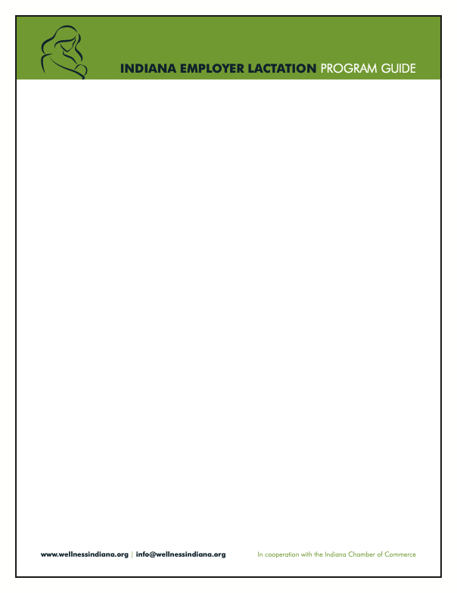

Sample Employee Lactation Support Handbook

Welcome to Your Lactation Support Resource Guide
Returning to work while breastfeeding can be challenging, but [company name] is committed to supporting your lactation needs. This handbook provides an overview of your rights, available resources and helpful tips for balancing work and breastfeeding.

Section 1: Your Rights as a Breastfeeding Mother
Under federal and Indiana laws, you have the right to:
- Reasonable break time to express breast milk
- Access to a private, non-bathroom space for milk expression
- Freedom from discrimination or retaliation for using lactation accommodations
Questions? Contact HR at [HR contact information]

Section 2: Lactation Space Access
- Location: [Insert location(s) of lactation rooms]
- Amenities available: Chair, table, electrical outlet, refrigerator access, privacy signage
- Scheduling breaks: Speak with your supervisor to coordinate lactation breaks
Tip: Plan your breaks around your usual feeding schedule to maintain milk supply

Section 3: Storing Breast Milk at Work
- Use your own clean, labeled containers
- Label each container with your name and date
- Store milk in the designated refrigerator or personal cooler
Safety trip: Breast milk can be safely stored in a refrigerator for up to four days

Section 4: Tips for Returning to Work While Breastfeeding
- Practice pumping before returning: Get comfortable with your breast pump
- Create a pumping routine: Consistency helps maintain milk supply
- Communicate openly: Let your manager know if your needs change
- Take care of yourself: Stay hydrated and eat well to support milk production
Reminder: Don’t skip pumping sessions; it may reduce your milk supply

Section 5: Support Resources
- Lactation consultants: [List local lactation support services]
- Peer support groups: [Include information on internal/external groups]
- HR contact information: [Insert contact info]
- EAP contact information: [Insert contact info]
- Breast pump coverage information (if applicable): [Insert contact info]


Section 6: Common Questions
- Q: How long can I use lactation accommodations?
  - A: Up to one year after your baby’s birth.
- Q: What if I face scheduling conflicts for lactation breaks?
  - A: Speak with your supervisor or HR to adjust your schedule.
- Q: What if I feel unsupported or face retaliation?
  - A: Contact HR immediately to resolve the issue.

Section 7: Lactation Break Plan Template
Use this section to plan your breaks:
- Usual pumping times: _____________ _____________ _____________
- Lactation room location: ___________________
- Storage plan: ____________________________

Quick Checklist for Employees
☐ Review the lactation policy
☐ Identify the lactation room locations
☐ Communicate your pumping schedule to your supervisor
☐ Bring your pump, storage containers and labels to work
☐ Stay consistent with breaks to maintain milk supply

Final note: Your well-being matters to us. If you encounter any challenges, reach out to HR or your supervisor.

We’re here to support you every step of the way.

Contact information:
- HR representative: [name, email, phone]
- Lactation room contact: [name, email, phone]

